**Report For Runlinc**

**(A case study for Information Voice Button)**

By

Afolayan Oluwatimilehin Israel

080-452

**Introduction**

In the rapidly advancing world of technology, user interfaces are evolving to become more intuitive and accessible. Voice-activated controls and information systems are at the forefront of this evolution, providing users with hands-free interaction capabilities that can enhance user experience and accessibility. This project, developed using Runlinc, aims to create an interactive voice button system that responds to various commands, each linked to specific actions or alerts. By integrating voice commands, we strive to create a more engaging and responsive interface.

## **Background**

Voice-activated systems have gained significant traction in recent years, primarily due to their convenience and the rise of smart home devices. These systems enable users to perform a variety of tasks using simple voice commands, making technology more accessible to people of all ages and abilities.

Runlinc, a web-based platform, offers a unique environment for developing and deploying such interactive applications. Leveraging its capabilities, this project involves the creation of a set of voice-activated buttons that trigger different responses, such as alerts or status updates.

The project features several key elements:

1. **Voice Commands**: Utilizing JavaScript and HTML, each button is programmed to respond to specific voice commands. This integration provides an easy and efficient way to control the application without manual input.
2. **Visual Indicators**: To complement the voice commands, visual indicators such as images and text are used to provide feedback and context to the user. These indicators help users understand the system's response and ensure a seamless interaction experience.
3. **Accessibility and Usability**: A primary focus of this project is to enhance accessibility for users with disabilities. By incorporating voice commands, users with limited mobility or visual impairments can interact with the application effectively.

Through this project, we aim to explore the potential of voice-activated technology in creating more inclusive and user-friendly interfaces. The Information Voice Buttons project serves as a testament to the capabilities of Runlinc in developing innovative web-based applications that cater to the diverse needs of users.

**Visual Content**

Screenshot of the codes used

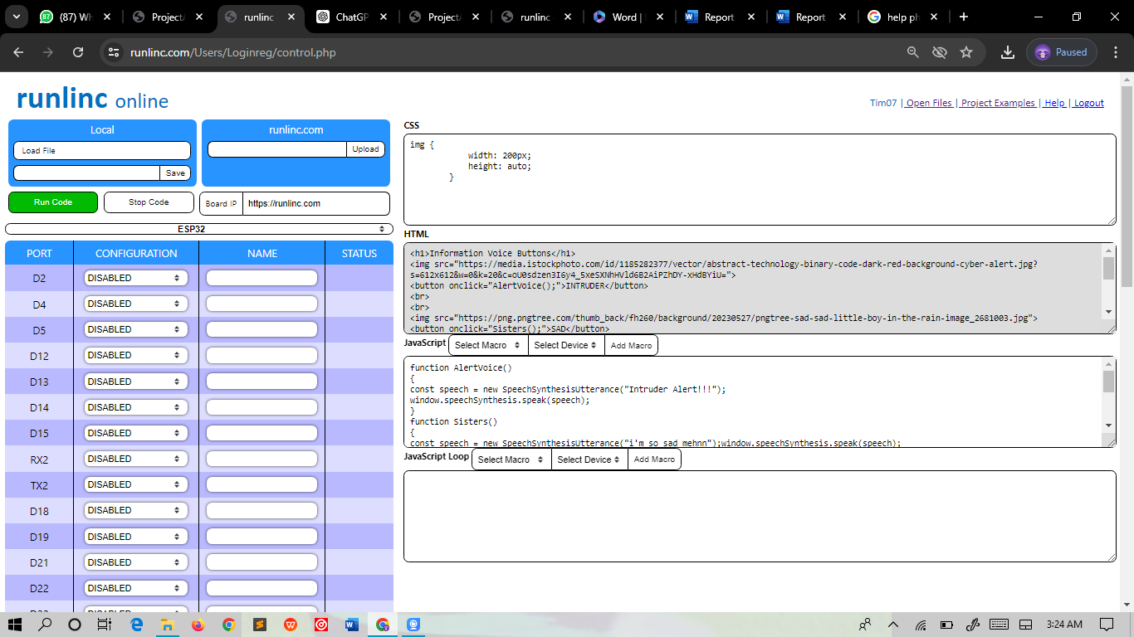

**CSS**

img {

width: 200px;

height: auto;

}

**HTML**

<h1>Information Voice Buttons</h1>

<img src="https://media.istockphoto.com/id/1185282377/vector/abstract-technology-binary-code-dark-red-background-cyber-alert.jpg?s=612x612&w=0&k=20&c=oU0sdzen3I6y4_5xeSXNhHVld6B2AiPZhDY-xHdBYiU=">

<button onclick="AlertVoice();">INTRUDER</button>

<br>

<br>

<img src="https://png.pngtree.com/thumb_back/fh260/background/20230527/pngtree-sad-sad-little-boy-in-the-rain-image_2681003.jpg">

<button onclick="Sisters();">SAD</button>

<br>

<br>

<img src="https://wallpapers.com/images/hd/yellow-ball-happy-smile-xx83mbjh8sbs4fql.jpg">

<button onclick="Happy();">HAPPY</button>

<br>

<br>

<img src="https://www.shutterstock.com/shutterstock/photos/608978792/display_1500/stock-vector-help-me-vector-banner-on-white-background-608978792.jpg">

<button onclick="Help();">Help</button>

**JavaScript**

function AlertVoice()

{

const speech = new SpeechSynthesisUtterance("Intruder Alert!!!");

window.speechSynthesis.speak(speech);

}

function Sisters()

{

const speech = new SpeechSynthesisUtterance("i'm so sad mehnn");window.speechSynthesis.speak(speech);

}

function Happy()

{

const speech = new SpeechSynthesisUtterance("lol, make sure to be happy oooo");

window.speechSynthesis.speak(speech);

}

function Help()

{

const speech = new SpeechSynthesisUtterance("Your help is really needed abeg");window.speechSynthesis.speak(speech);

}

**OUTPUT**

